**Final Project**

**Create table in mysql**

create table tripdata(VendorID int, tpep_pickup_datetime datetime, tpep_dropoff_datetime datetime, passenger_count int,trip_distance float,

Pickup_longitude float, pickup_latitude float, RateCodeID int, store_and_fwd_flag varchar(10), dropoff_longitude float, dropoff_latitude float, payment_type int, fare_amount float, extra float, mta_tax float, tip_amount float, tolls_amount float, total_amount float, trip_time float)ROW FORMAT DELIMITED FIELDS TERMINATED BY "," LINES TERMINATED BY "\n";

**Load data in mysql**

load data local infile '/root/tripdata.csv' into table tripdata FIELDS TERMINATED BY "," ENCLOSED BY "" LINES TERMINATED BY "\n" IGNORE 1 ROWS;

RDS

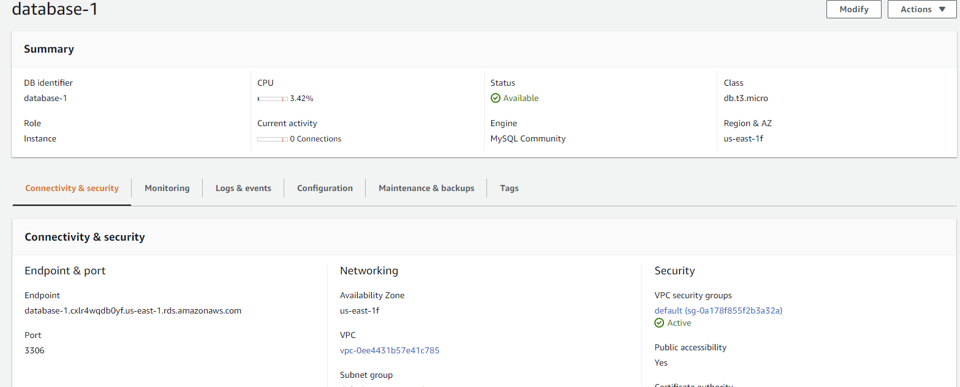

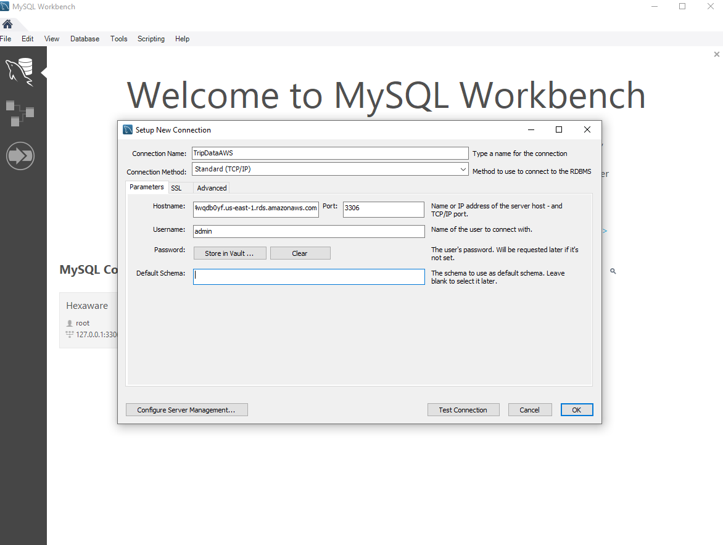

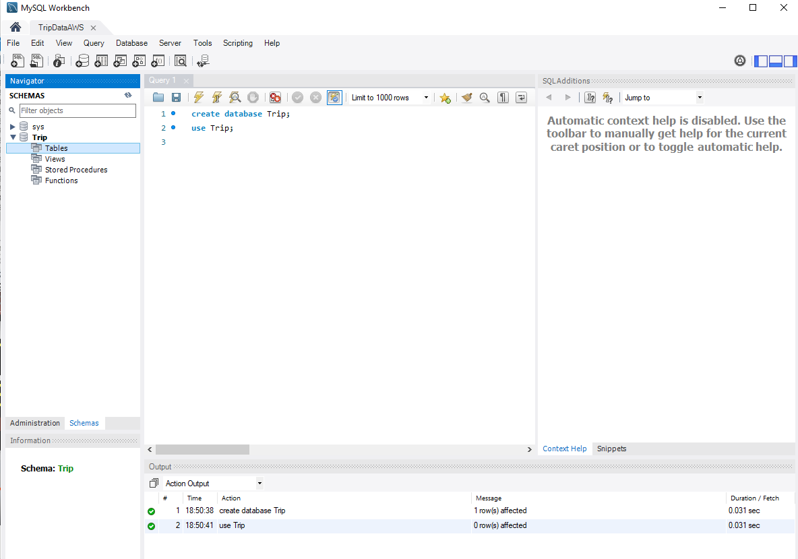

**Sqoop command (for localhost)**

sqoop import --connect jdbc:mysql://localhost:3306/my_data --driver com.mysql.jdbc.Driver --table tripdata -m 1 --username root --password Dhrumil@123 --hive-import

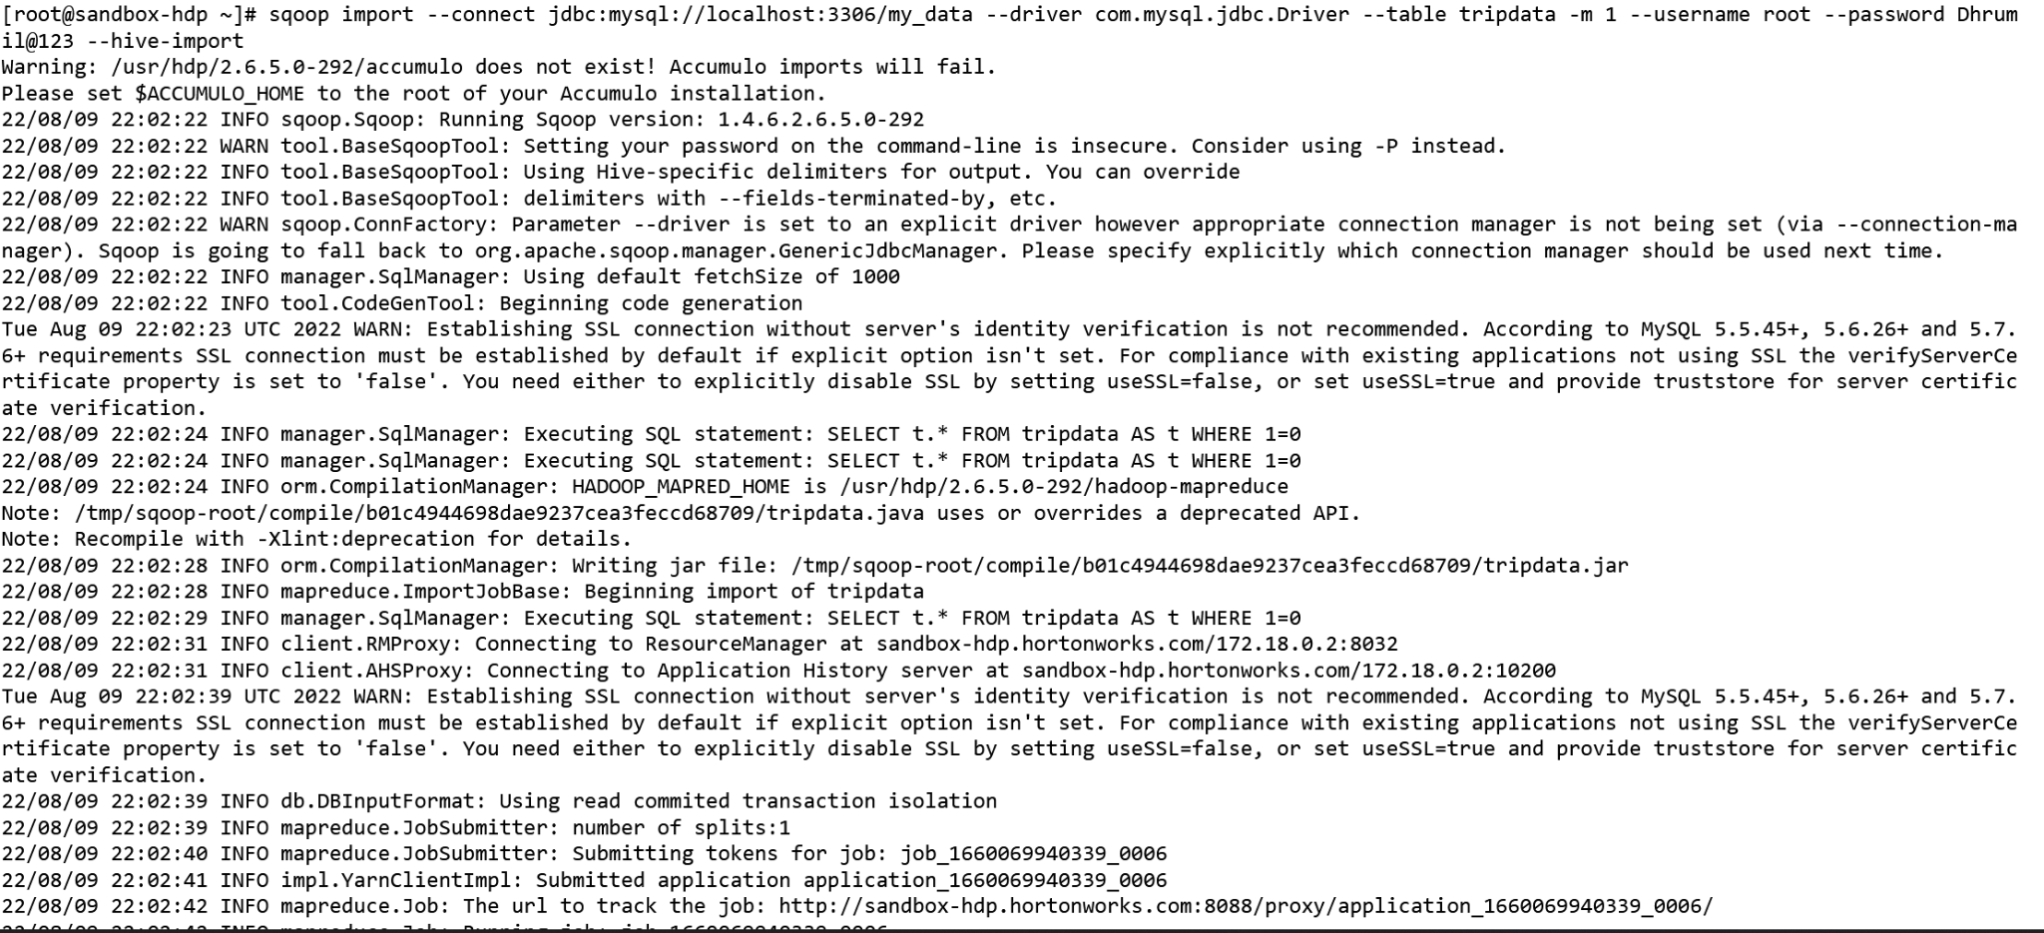

**Hive table view of the first 10 rows**

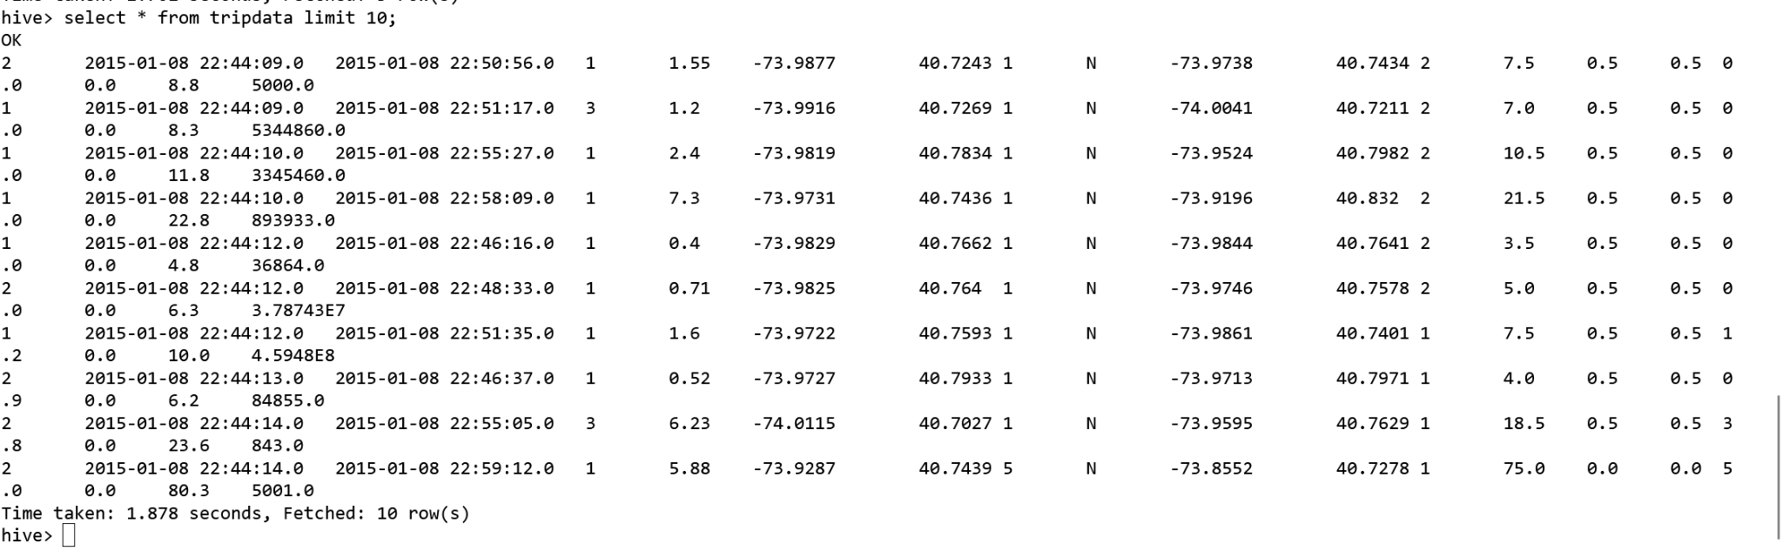

1. **What is the total number of trips (equal to the number of rows)?**

select count(VendorID) from tripdata;

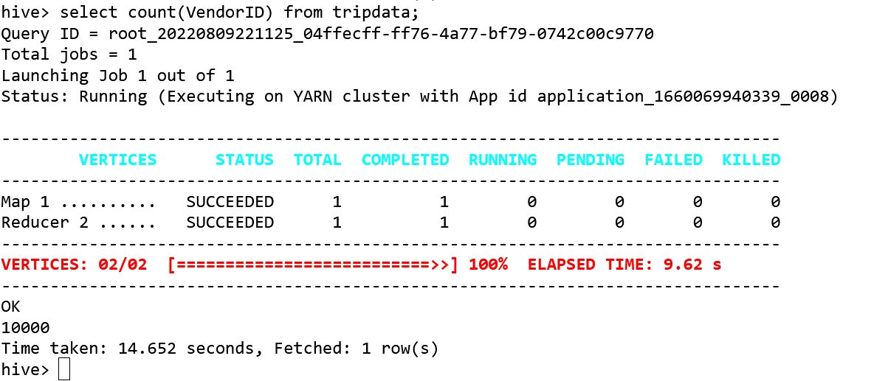

**What is the total revenue generated by all the trips?**

select sum(total_amount) from tripdata;

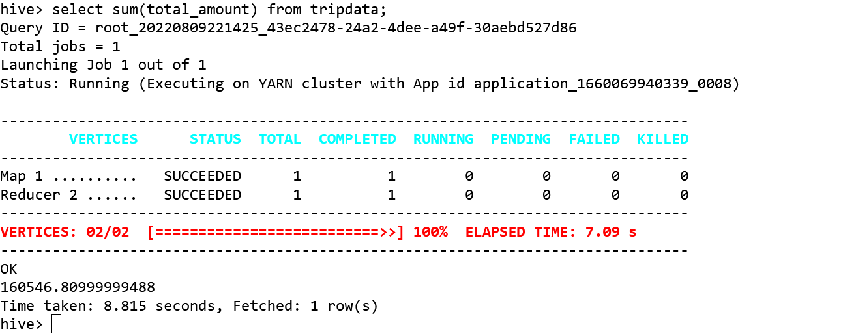

**What fraction of the total is paid for tolls?**

**Row-wise**

select tolls_amount, total_amount, tolls_amount/total_amount * 100 as percent_fare_amount from tripdata;

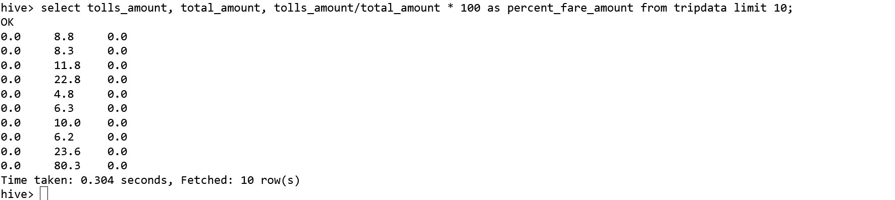

**Total**

select sum(tolls_amount)/sum(total_amount) * 100 as percent_fare_amount from tripdata;

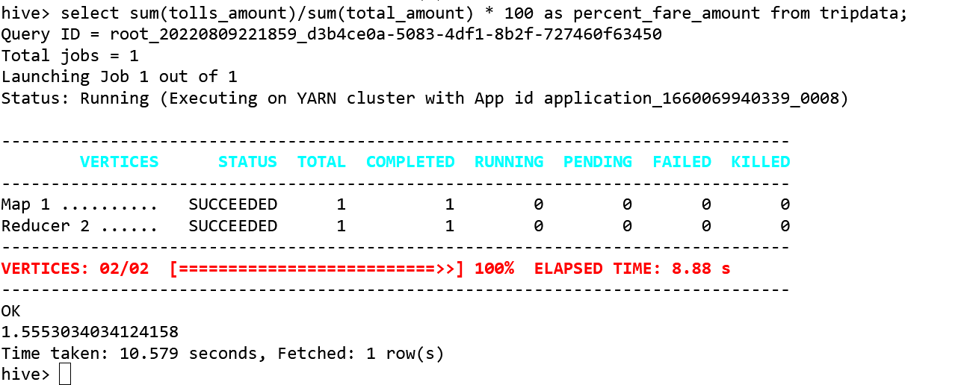

**What fraction of it is driver tips?**

**Row-wise**

select vendorid,tip_amount,total_amount, tip_amount/total_amount *100 as percent_tip_amount from tripdata;

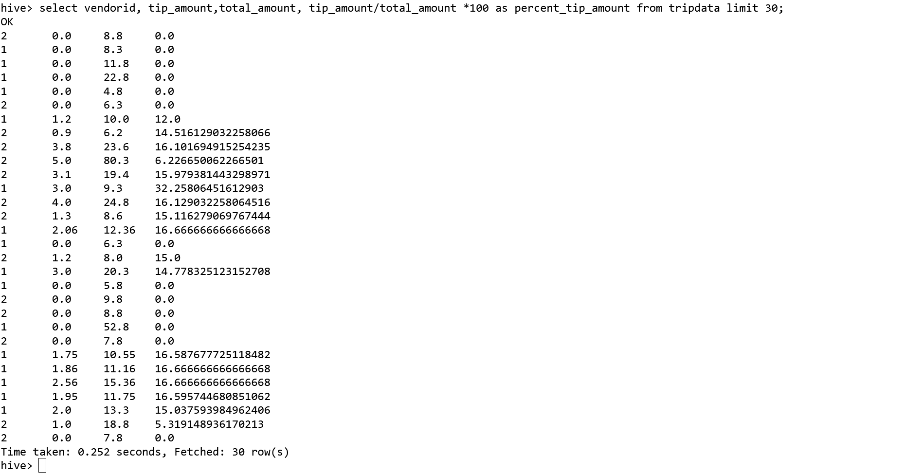

**total**

select sum(tip_amount)/sum(total_amount) *100 as percent_tip_amount from tripdata;

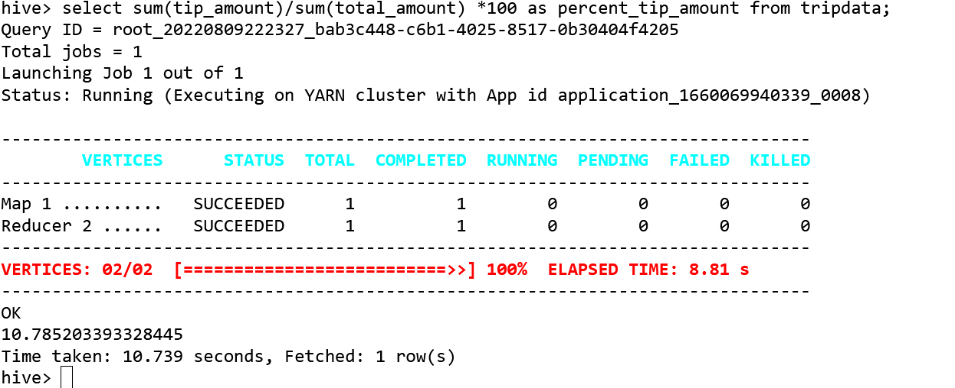

**What is the average trip amount?**

select avg(fare_amount) as average_trip_amount, avg(trip_distance) as average_distance, avg(trip_time) as average_time from tripdata;

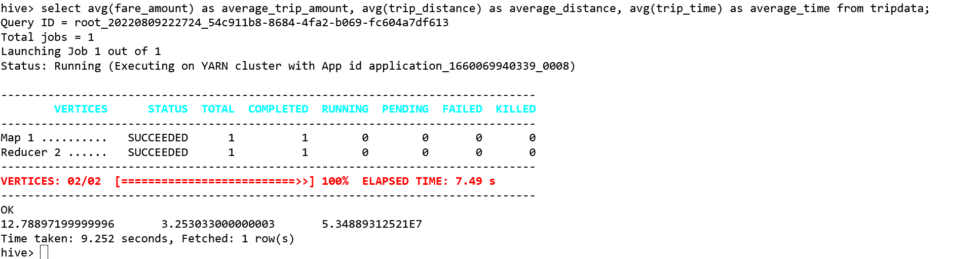

**What is the average distance of the trips?**

select avg(trip_distance) as average_distance from tripdata;

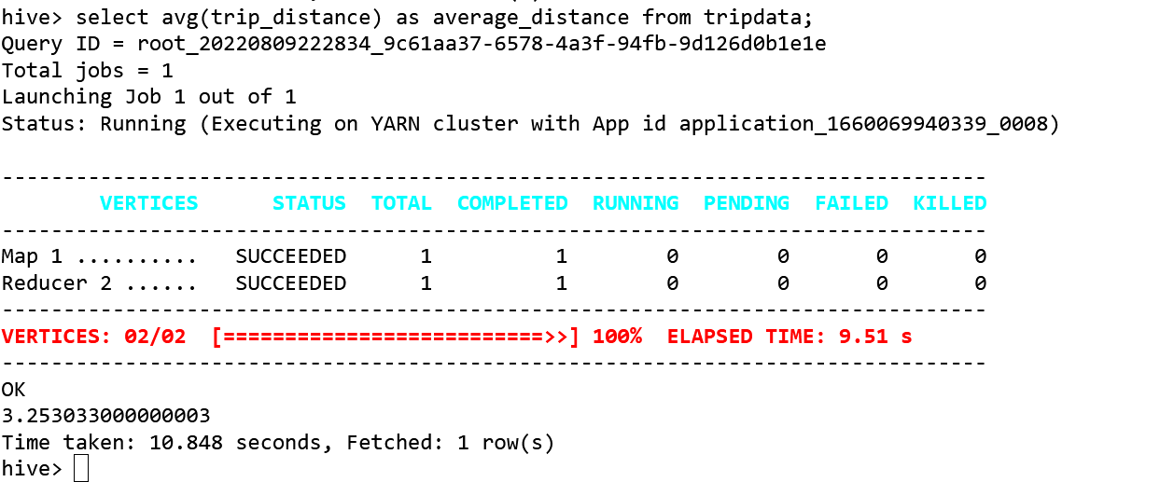

**How many different payment types are used?**

select distinct(payment_type) as payment_type from tripdata;

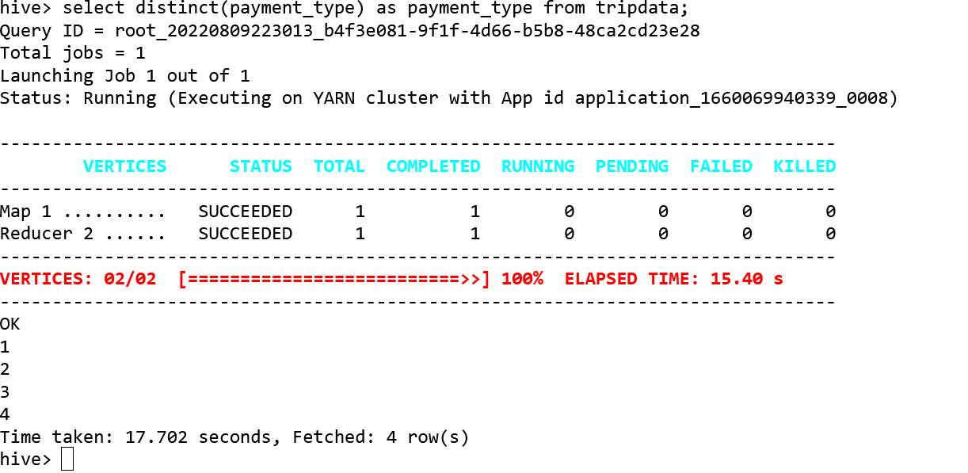

**For each payment type, display the following details:**

1. **Average fare generated**
2. **Average tip**
3. **Average tax**

select avg(fare_amount), avg(tip_amount), avg(mta_tax), payment_type from tripdata group by payment_type;

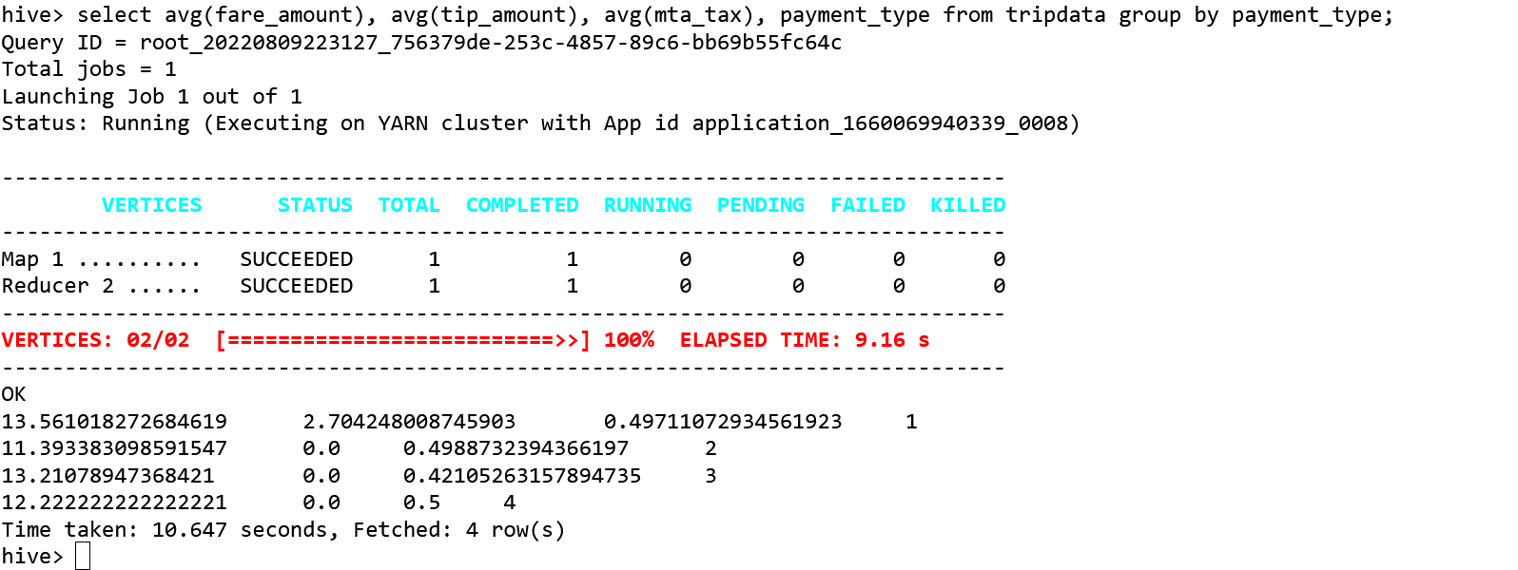

**On average which hour of the day generates the highest revenue?**

select sum(total_amount), hour(tpep_pickup_datetime) from tripdata group by hour(tpep_pickup_datetime);

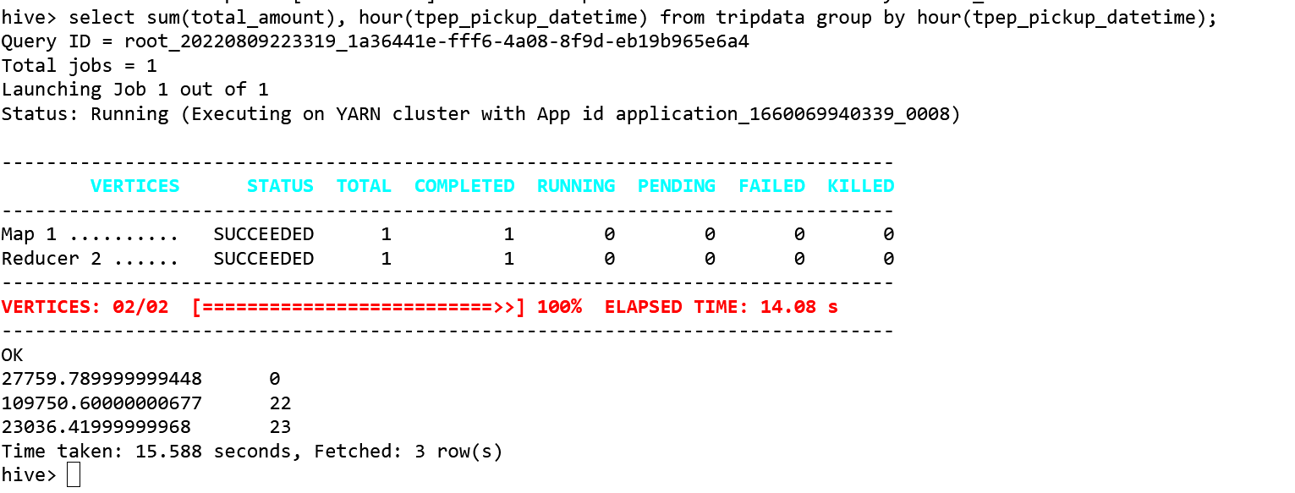

ct avg(fare_amount), avg(tip_amount), avg(mta_tax), payment_type from tripdata group by payment_type; the trips